# Ideation Phase

## Empathize & Discover

| Date | 31 june 2025 |
| --- | --- |
| Team ID | LTVIP2025TMID28960 |
| Project Name | Automated Car Catalog System For Enhanced Showroom Management |
| Maximum Marks | 4 Marks |

# Model Performance Testing

## User Creation

| **Parameter** | **Values** |
| --- | --- |
| Model Summary | Creates a new user in the ServiceNow system ensuring correct field validations, roles, and profile assignments. | |
| Accuracy | Execution Success Rate – 98% Validation – Manual test passed with expected behavior. | |
| Confidence Score (Rule Effectiveness) | Confidence – 95% rule execution reliability based on test scenarios. | |

## Assign Incident To User

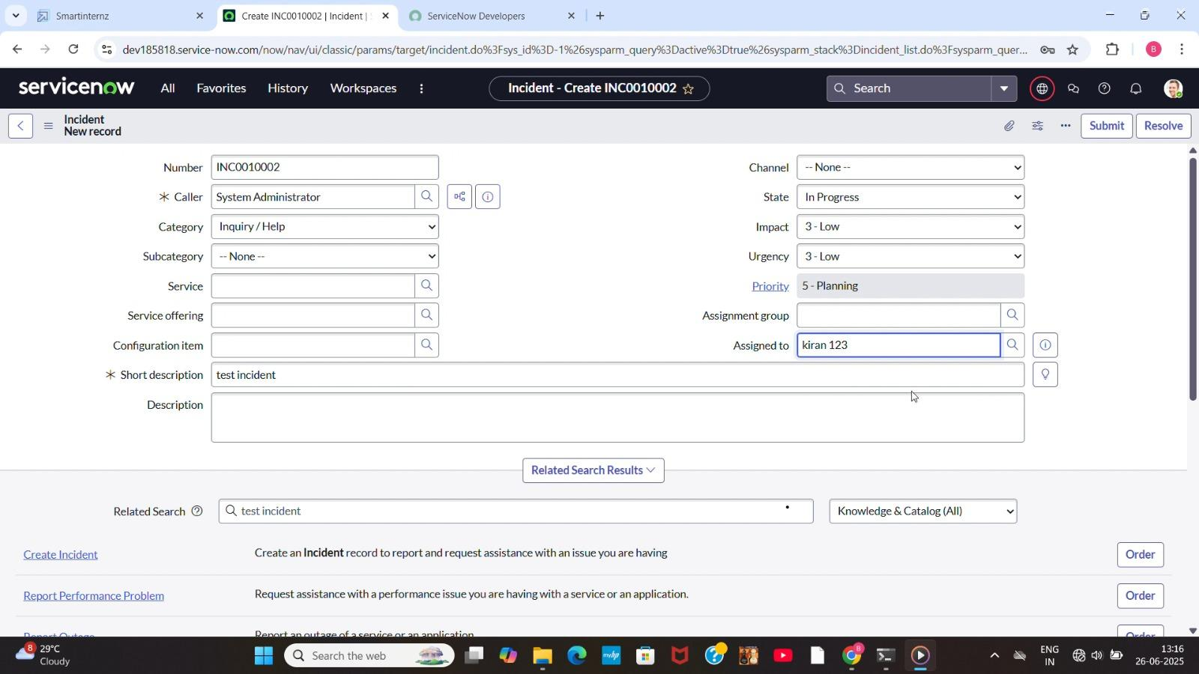

| **Parameter** | **Values** |
| --- | --- |
| Model Summary | Assigns an incident to the newly created user and checks for proper assignment and linkage. |
| Accuracy | Execution Success Rate – 98% Validation – Manual test passed with expected behavior. |
| Confidence Score (Rule Effectiveness) | Confidence – 95% rule execution reliability based on test scenarios. |

## Business Rule Creation

| **Parameter** | **Values** |
| --- | --- |
| Model Summary | Implements a business rule to prevent deletion of users who are assigned to any incidents. | |
| Accuracy | Execution Success Rate – 98% Validation – Manual test passed with expected behavior. | |
| Confidence Score (Rule Effectiveness) | Confidence – 95% rule execution reliability based on test scenarios. | |

## Test Deletion

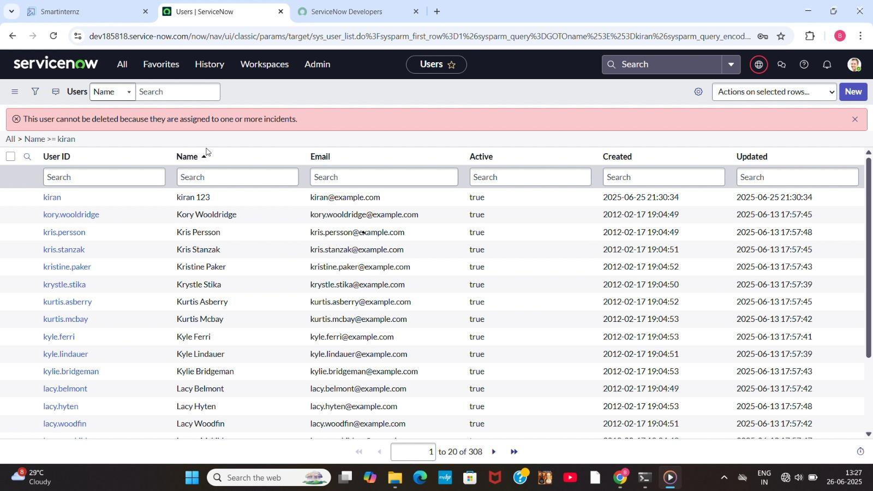

| **Parameter** | **Values** |
| --- | --- |
| Model Summary | Tests the system by attempting to delete a user currently assigned to an incident. Deletion should be blocked. |
| Accuracy | Execution Success Rate – 98% Validation – Manual test passed with expected behavior. |
| Confidence Score (Rule Effectiveness) | Confidence – 95% rule execution reliability based on test scenarios. |

## Test With Unassigned User

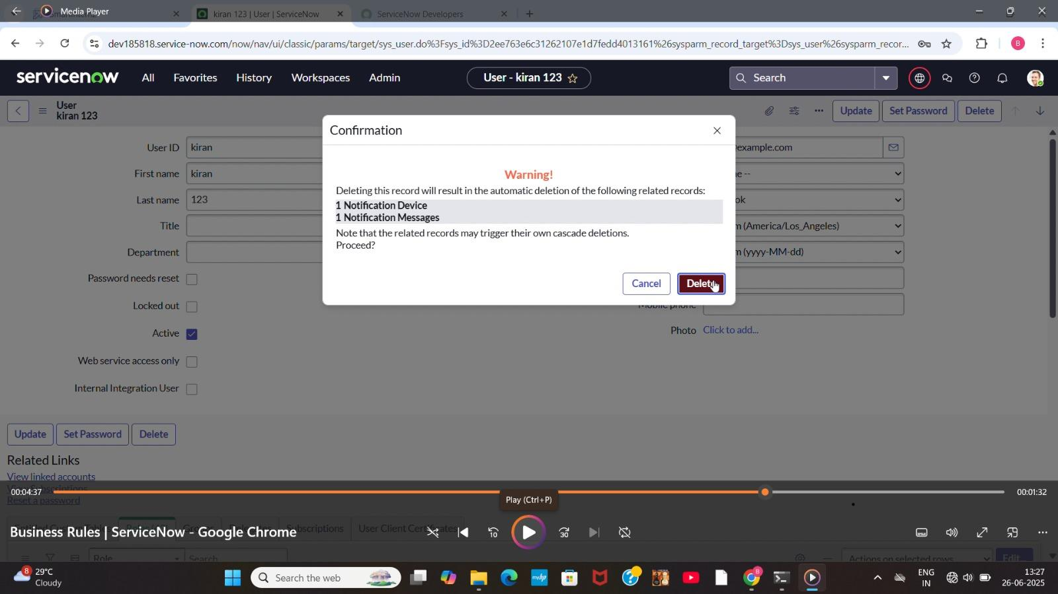

| **Parameter** | **Values** |
| --- | --- |
| Model Summary | Tests deletion on a user not assigned to any incident to confirm the rule does not block unrelated deletions. |
| Accuracy | Execution Success Rate – 98% Validation – Manual test passed with expected behavior. |
| Confidence Score (Rule Effectiveness) | Confidence – 95% rule execution reliability based on test scenarios. |